To be diagnosed with a kidney tumor is frightening at best, and the first impulse is to get it out. Seems sensible from all angles, and the relief of hearing, “I got it all” lets the patient breathe again.

But the “all” doesn’t happen in all cases, despite the best hopes and intentions of the surgeon. Both patient and doctor need to be aware how frequently that announcement is wrong. First of all, doctors digging through a tumor cannot see all cancerous cell, thus the need to take out more—the margin—around the tumor.

Many variable affect the visibility of any tumor, and the type of imaging used to fnd one tumor may not reveal another. There are many reasons not to be surprised by need for additional imaging. A greater concern may be if the doctor says that annual chest x rays will be adequate to watch for lung nodules, a favorite site for kidney metastases to settle!

Chest x ray Generally, a pulmonary nodule must grow to at least 1 cm in diameter before it can be seen on a chest X-ray film. Per emedicinehealth.com 2.54cm per inch, so about 3/8” in size

MAYO Clinic: The smallest lesion that can be felt by hand is typically 1.5 to 2 centimeters (about 1/2 to 3/4 inch) in diameter.

Tumor size
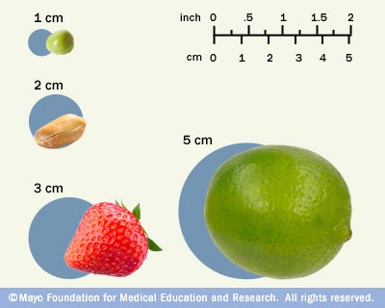

Centimeter and millimeter measuring in medicine

Another of those new language issues; not just new words, but new number and measurement system. Start by remembering that a big pea is about a centimeter, and those tiny or adolescent peas are millimeter sizes. Two inches is about 5 centimeters, or about the size of decent lime.

One centimeter tumor contains 1 billion cells. Did one or two escape?

To keep things tricky, tumors don’t grow in neat balls shapes, often more like potatoes than oranges. This gives a better visualization of the volume issues which are discussed in tumor shrinkage. Coming down in size 20% may could mean a 5cm tumor becomes a 4cm tumor, or a 5cm x 4cm x 2cm tumor, roughly 40cm in volume could be now 4cm x 4cm x 2 cm, or 32cm in volume.

After your surgery, your tumor will be measured, using the greatest dimension as its measure in most cases. Thus, it will be hard to get an exact sense of the size of it. Smaller is better.

Any patient diagnosed with a small tumor is grateful to hear it is small, that small is better, and the magical “got it all” promise. But can such a promise be kept? Frankly, the answer is no. More and more small renal masses are found, thanks to the improved types of imaging we have, and the willingness to use it. Many of those masses are found incidental to the reason for the imaging.

The incidence of these findings is greater, and oddly, the incidence of clear cell tumors, previously estimated to be 85% of such tumors, is dropping. Now only about 60-65% of such tumors are thought to be clear cell, which naturally means that the more rare variants, are less rare than had been thought. Some of these rarer variants are more indolent, more slowly growing, and may never have become symptomatic and looked for, hiding their greater frequency. This just adds to the confusion, of course.

Ultrasound is less sensitive, with studies showing that lesions of 3cm or less are seen about 94% of the time by CTs, and only 79% of the time by ultrasounds.

